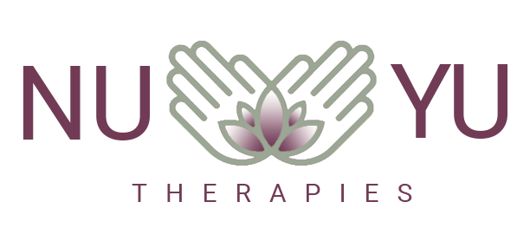

**WHAT YOUR TREATMENT VISIT WILL LOOK LIKE**

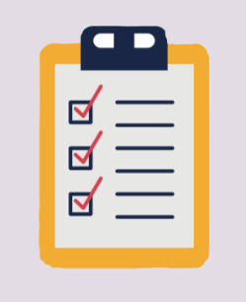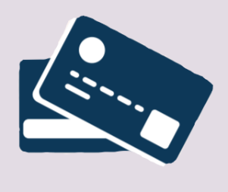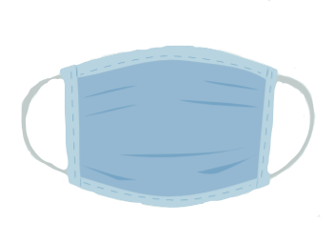When you attend the practice, there will be some new protection measures in place. We understand that some of these might seem a little strange at first, so please read on to see how you can help us keep everyone safe.

**DEPARTURE**

When the treatment is over, please leave all linens on the couch. Cash payments must be

made with the correct amount

as change will not be available.

Aftercare and future

appointments will be made

over the telephone.

Use the sanitiser on the way out.

**SYMPTOMS**

Firstly, if you are experiencing

any Covid-19 symptoms,

please postpone or cancel

your appointment

**CONSULTATION**

Initial and update consultations will

take place via phone or online,

prior to your appointment to

discuss your needs and any

Covid-19 issues. All documents and

consents should be signed and

brought with you to your

appointment or emailed beforehand.

**PRECATUIONS**

The treatment room will have been thoroughly disinfected and all linen and towels replaced for each client. I will be wearing personal protective equipment and you will

be required to wear a

mask (can be provided).

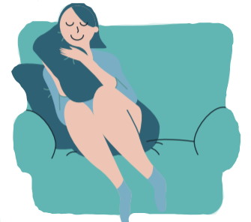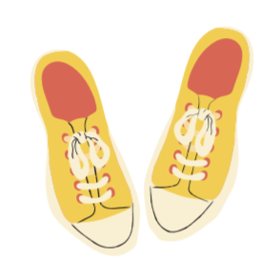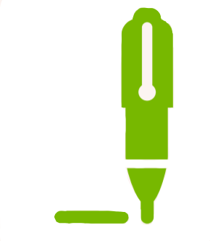

Hopefully in the near future things will return back to normal and not feel so clinical and alien. Thank you for your continued support and patience at this weird time.

**TREATMENT**

Upon arrival, you will be required

to remove your shoes outside

of the treatment room, and

enter the practice room without

touching anything. There will be

a container in which to put your

clothes if you need to undress

for massage.

**CONSENT**

There will be a consent form to

complete regarding your exposure

to Covid-19, this will be sent

via email prior to your appointment.

If you are considered a high-risk

client, it may not be possible to

treat you